School Tours for Prospective Familes
2023 and 2024 Tours
Tuesday, Dec. 12, 2023: 0900
Tuesday, Jan. 9, 2024: 0900
Tuesday, Feb. 13, 2024: 0900
Tuesday, March 12, 2024: 0900
Tuesday, April 9, 2024: 0900
Tuesday, May 7, 2024: 0900

CLICK HERE TO JOIN US:
https://www.signupgenius.com/go/10C084BA9AF28A6FEC52-45958004-shes

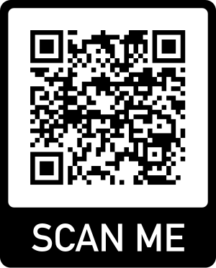

If you have any questions, please contact Mrs. Jamila Stewart at 678-874-7502.

